BLOGPOST - How much Equity Universities take in Start-ups from IP Licensing

How much equity universities take in start-ups for a license of intellectual property? It is sometimes not to say often a hot topic and information is not easy to obtain. However there are some standards or common practice. I have already published posts on the topic: University licensing to start-ups in May 2010 followed by a Part 2 in June 2010.

To oversimplify, I used to say that the license was made of 3 components:
– first, universities take about 5% post-series A (a few million $) or similarly about 10% at creation (investors often take half of the company at round A,)
– second, there is also a royalty based on sales of products using the licensed technology, about 2% but the range might be 0.5% to 5%. A minimum yearly amount is usually asked for, like $10k or more.
– third, a small but important detail: start-ups pay for the maintenance of the IP from the date of the license.
I decided to look at data again through the S-1 documents, which start-ups write when they prepare their Initial Public Offering (IPO), usually on Nasdaq. I found about 30 examples of academic spin-offs which gave details about the IP license. Here is the result.

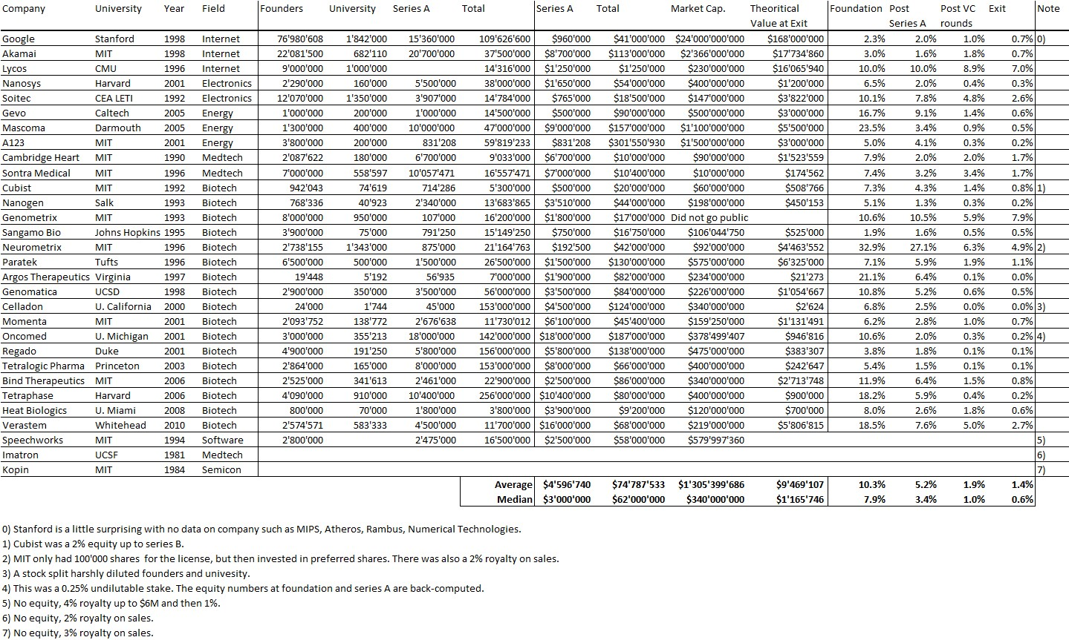
(Click on picture to enlarge)

A couple of comments:

This was not an easy exercise and I would not claim it is mistake-free. You should read it as indicative only, hopefully it is mostly accurate! Assuming the data is accurate, universities own about
– 10% at creation or
– 5% post–series A (average: $5M)
– Universities keep a 1-2% equity stake at exit,
– Worth a few $M (Median is $1M)
With an average of $70M VC investment and market value in the $1B range (Median is $300M)
(Median values are as important as Averages).
Royalties are in the 1-4% range.
All this is consistent with information given in my prior posts!
You can also check the following Slideshare document

SEE SLIDESHARE:

University Equity in Start ups for IP Licensing - Lebret - nov 2013

